IT 140
Jonathan Ayala

Imperial Nightmare Game

Welcome to “Imperial Nightmare”! You are an Imperial guardsman traveling back home on a spaceship, with your fellow guardsmen after a five yearlong mission. You are in your living quarters, and you suddenly awaken from your sleep realizing half of your crew is dead and the other half is missing. You then realize that they are being hunted and captured by a figure known as a Chaos Space Marine. To save the rest of your crew and make it back home, you must defeat the Chaos Space Marine in the Command Center.

To defeat him, first you must retrieve a MAP from the Cafeteria to help you navigate the spaceship. A HELMET from the War Room, ARMOR from the Armory, BOLTER AMMO from the Trophy Room, A GRENADE from the LAB, and a BOLTER GUN from the Captain’s Chambers. If you do not retrieve all these items, the Chaos Space Marine will be too powerful to defeat, and you and your guardsmen will never see home again.

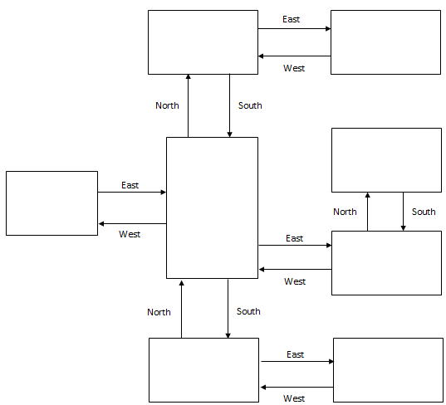
Command Center (Chaos Space Marine)
END
Captain’s Chambers
ITEM: Bolter Gun
LAB
ITEM: Grenade
Trophy Room
ITEM: Bolter Ammo
Armory
ITEM: Armor
War Room
ITEM: Helmet

Cafeteria
ITEM: Map
Living Quarters
START

Pseudocode or Flowchart for Code to “Move Between Rooms”

START at Living quarters
IF player move EAST
Enter “Cafeteria”
ELSE
DISPLAY “Invalid Direction”

IF player in Cafeteria
IF player move North
ENTER “War Room”
ELIF player move South
ENTER “Captain’s Chambers”
ELIF player move EAST
ENTER “Trophy Room”
ELIF player mover West
ENTER “Living Quarters”

IF player in War Room
IF player move East
ENTER “Armory”
ELIF player move South
ENTER “Cafeteria”
ELSE
DISPLAY “Invalid Direction”

If player in Armory
IF player move West
Enter “War Room”
ELSE
DISPLAY “Invalid Direction”

IF player in Trophy Room
IF player move North
ENTER “Lab”
ELIF player move West
ENTER “Cafeteria”
ELSE
DISPLAY “Invalid Direction”

IF player in Lab
IF player move South
ENTER “Trophy Room”
ELSE
DISPLAY “Invalid Direction”

IF player in Captain’s Chambers
IF player move East
ENTER “Command Center”
ELIF player move North
ENTER “Cafeteria”
ELSE
DISPLAY “Invalid Direction”

IF in Command Center
IF player move West
ENTER “Captains Chambers”
ELSE
DISPLAY “Invalid Direction”
END at Command Center by either defeating the Chaos Space Marine or dying!

Pseudocode or Flowchart for Code to “Get an Item”

START by entering a room
IF room has an item []
DISPLAY “Added to inventory!”
ELSE
DISPLAY “No item discovered. Move to next room.”

